Let us create a simple sample graph:
- use the stats system to enter 51 coordinates for two cycles of a sine wave.
- inspect the STATS matrix thus created below.
- draw the graph.
For convenience, the eRPN commands are written in-line, as typed.
Tip: I used battery power to test the program, but I would rather suggest USB power - matrix generation and graph preparation are quite a bit quicker on USB power:
First, set up, clear stats and create a loop counter R00 from 51 to 1 to create 51 coordinate points. I chose 51, because 25 x-points will be negative, 1 will be zero and 25 x-points will be positive.

f[PRGM] g[GTO] .. g[LBL] 𝛼 SIN_EX ENTER
f[STAT] g[CLΣ]
f[MODE] [RAD]
51 STO 00
g[LBL] 𝛼 LOOP1 ENTER

(of course the g-shift was needed to get the number 1 (in LOOP1) in alpha mode)
Now scale the counter to produce an x value in radians, from -2𝝿 to 2𝝿, by doing: {[(R00 – 1) / -25] + 1} * 2𝝿
RCL 00 1 –
25 CHS ÷ 1 + 2
f[𝜋] × ×

Calculate the function y = sin (x), and swap to get y in Y and x in X
ENTER
SIN
x⇄y
Use Σ+ to add the coordinate point to the stats system and therefore to the STATS matrix.
Σ+

Repeat the loop, decrementing the loop counter until 0, and skip if 0
g[LOOP] DSZ 00
g[GTO] 𝛼 LOOP1 ENTER
g[RTN] f[PRGM]

Now, set your favourite display mode, mine is
f[DISP] SIG 3

and run the program:
XEQ PROG S [SIN_EX]

After about 10 seconds the 51 points are written and you can check the points:
RCL VAR S STATS

After seeing the 51x2 matrix, you can plot it. There was no need to recall the matrix, it was only to demo matrix recall.
Plot using the dedicated scientific graphing,

g[PLOT] PLSTAT

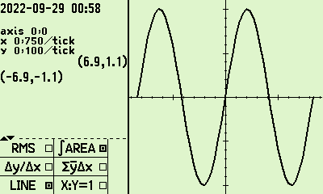

Exercise: Go back to the program, and change the function from sin to sinc (from the f[MODE] TRIG menu) and plot it.

Reference: C43 graphing example listed in the Forum:
https://forum.swissmicros.com/viewtopic.php?f=2&t=2216&p=24433&hilit=Our+next+release+is+available%2C+mostly#p24433
Author Jaco Mostert
Copyright (C) 2023 The C47 Development Team. Permission is granted to copy, distribute and/or modify this document under the terms of the GNU Free Documentation License, Version 1.3 or any later version published by the Free Software Foundation; with no Invariant Sections, no Front-Cover Texts, and no Back-Cover Texts. A copy of the license can be downloaded from gnu.org.

